Lab 4 Report: Informed Search, Heuristics & A*
CAI601400 - Artificial Intelligence
Field | Detail
Name | Moiez Ali Khan
Roll Number | SU92-BSAIM-F25-250
Section | 03-D
GitHub Repository | https://github.com/moiezkhan707-cmyk/AI-lab-tasks
Lab Folder | Lab04/

1. Problem Statement
A campus navigation system knows the actual travel cost so far and an estimate of the remaining cost. It should reach a destination while expanding fewer irrelevant states than an uninformed search. This lab implements A* search, which orders the frontier by f(n) = g(n) + h(n), and compares it with uniform-cost search (UCS) on the same weighted graph. It then checks the heuristic for admissibility and consistency, and studies what happens when one heuristic value overestimates the true remaining cost.

2. Assumptions and Conventions
- The graph and heuristic are the ones supplied in the manual: S is the start building and G is the destination. Edge weights and h values are abstract travel-time units, not measured campus distances.
- Queue tie-breaking: smaller f first, then smaller g, then node name. Successors are examined in the listed order.
- Counting convention for both A* and UCS: a node is expanded only when its successors are examined. Goal processing is logged but not counted as an expansion. Stale queue entries are ignored and counted separately.
- UCS is obtained from the same A* code by setting every heuristic value to zero, so only the heuristic differs between the two runs.

3. Graph and Heuristic
Node | Successors (cost) | h(n) | True remaining cost
S | A (1), B (4) | 5 | 6
A | C (2) | 4 | 5
B | G (5) | 4 | 5
C | G (3) | 2 | 3
G | none | 0 | 0

There are two complete routes: S -> A -> C -> G costs 1 + 2 + 3 = 6, and S -> B -> G costs 4 + 5 = 9. The true remaining costs in the table are the cheapest cost from each node to G.

4. Task 1: Manual g, h and f for the First Three Expansions
Rule used: g is the accumulated cost from S, h is the supplied estimate, and f = g + h. The frontier node with the smallest f is selected next.
Expansion | Selected node (g, h, f) | Calculations and new frontier entries | Why the next node is chosen
1 | S (0, 5, 5) | f(S) = 0 + 5 = 5. Successor A: g = 0 + 1 = 1, f = 1 + 4 = 5. Successor B: g = 0 + 4 = 4, f = 4 + 4 = 8. Frontier: A(f=5), B(f=8). | A has the smallest f (5 < 8).
2 | A (1, 4, 5) | f(A) = 1 + 4 = 5. Successor C: g = 1 + 2 = 3, f = 3 + 2 = 5. Frontier: C(f=5), B(f=8). | C has the smallest f (5 < 8).
3 | C (3, 2, 5) | f(C) = 3 + 2 = 5. Successor G: g = 3 + 3 = 6, f = 6 + 0 = 6. Frontier: G(f=6), B(f=8). | G has the smallest f (6 < 8), so G is processed next.

The computed values match the code trace in Section 6.1. Node G is then processed as the goal with cost 6, and B (f = 8) is never expanded.

5. Heuristic Audit

5.1 Admissibility (supplied heuristic)
Node | h(n) | True remaining cost | h <= true cost?
S | 5 | 6 | Yes
A | 4 | 5 | Yes
B | 4 | 5 | Yes
C | 2 | 3 | Yes
G | 0 | 0 | Yes

5.2 Consistency, h(u) <= cost(u, v) + h(v), for each edge
Edge | h(u) | cost | cost + h(v) | Check | Result
S -> A | 5 | 1 | 5 | 5 <= 5 | Yes
S -> B | 5 | 4 | 8 | 5 <= 8 | Yes
A -> C | 4 | 2 | 4 | 4 <= 4 | Yes
B -> G | 4 | 5 | 5 | 4 <= 5 | Yes
C -> G | 2 | 3 | 3 | 2 <= 3 | Yes

The supplied heuristic is admissible on this small instance, verified explicitly, and it passes every consistency edge check. Edges S -> A and A -> C hold with equality, which means h is exactly tight there.

6. Task 2: A* vs UCS

6.1 A* with the supplied heuristic
Step | Node | g | h | f | Status | Frontier after step
1 | S | 0 | 5 | 5 | expanded | A(g=1, h=4, f=5); B(g=4, h=4, f=8)
2 | A | 1 | 4 | 5 | expanded | C(g=3, h=2, f=5); B(g=4, h=4, f=8)
3 | C | 3 | 2 | 5 | expanded | G(g=6, h=0, f=6); B(g=4, h=4, f=8)
4 | G | 6 | 0 | 6 | goal (not counted) | B(g=4, h=4, f=8)

6.2 UCS control (all h = 0)
Step | Node | g | h | f | Status | Frontier after step
1 | S | 0 | 0 | 0 | expanded | A(g=1, h=0, f=1); B(g=4, h=0, f=4)
2 | A | 1 | 0 | 1 | expanded | C(g=3, h=0, f=3); B(g=4, h=0, f=4)
3 | C | 3 | 0 | 3 | expanded | B(g=4, h=0, f=4); G(g=6, h=0, f=6)
4 | B | 4 | 0 | 4 | expanded | G(g=6, h=0, f=6)
5 | G | 6 | 0 | 6 | goal (not counted) | empty

6.3 Comparison
Measure | A* (supplied h) | UCS (h = 0)
Returned path | S -> A -> C -> G | S -> A -> C -> G
Reported cost | 6 | 6
Independently summed cost | 1 + 2 + 3 = 6 | 1 + 2 + 3 = 6
Processing order | S, A, C, G | S, A, C, B, G
Nodes expanded (goal excluded) | 3 | 4
Stale entries ignored | 0 | 0

Both runs return the same optimal path with cost 6. A* expands 3 nodes (S, A, C) and UCS expands 4 (S, A, C, B). The difference is node B: UCS expands it because its g = 4 is smaller than the goal's g = 6, while A* leaves it unexpanded because f(B) = 8 is larger than f(G) = 6. In both runs there were no stale entries, and the goal was processed but not counted, so the counting convention is the same. This efficiency claim comes from the measured trace on this one small graph and should not be generalised to other graphs.

7. Task 3: Overestimating Heuristic

7.1 Experiment: h(C) = 10
Changed node | Original h | Modified h | True remaining cost
C | 2 | 10 | 3 (overestimate by 7)

Step | Node | g | h | f | Status | Frontier after step
1 | S | 0 | 5 | 5 | expanded | A(g=1, h=4, f=5); B(g=4, h=4, f=8)
2 | A | 1 | 4 | 5 | expanded | B(g=4, h=4, f=8); C(g=3, h=10, f=13)
3 | B | 4 | 4 | 8 | expanded | G(g=9, h=0, f=9); C(g=3, h=10, f=13)
4 | G | 9 | 0 | 9 | goal (not counted) | C(g=3, h=10, f=13)

Measure | Original (h(C) = 2) | Modified (h(C) = 10)
Returned path | S -> A -> C -> G | S -> B -> G
Cost | 6 | 9
Nodes expanded | 3 | 3
Admissible? | Yes | No (h(C) = 10 > 3)
Consistent? | Yes | No (edge C -> G: 10 > 3 + 0)

With h(C) = 10, node C gets f = 3 + 10 = 13, which looks worse than B (f = 8) and then G through B (f = 9). A* therefore processes G with cost 9 through B before it ever examines C, and returns S -> B -> G instead of the cost-6 route. The path and cost changed, and the cost is 3 units worse. The number of expanded nodes stayed at 3, but it is a different set (S, A, B), so a count alone would have hidden the damage.

7.2 Supplementary: h(B) = 10 (true remaining cost 5)
Changing only h(B) to 10 also overestimates (10 > 5), but the result is unchanged: path S -> A -> C -> G, cost 6, 3 expansions. Here the overestimate pushes B further back, which does not hurt because B was not on the optimal route.

7.3 Why an overestimate removes the guarantee
The optimality guarantee of A* relies on h never overestimating. A node on the optimal route with an inflated h gets a larger f than it deserves, so the search can reach the goal through a worse route first and stop. The h(B) = 10 run shows that an overestimate sometimes leaves the answer unchanged, but that is luck: it depends on whether the inflated node lies on the optimal route. A single unchanged run therefore does not prove a heuristic is safe, which is why the heuristic was checked explicitly in Section 5.

8. Code and Captured Output

8.1 Code: lab4.py
"""Lab 4: Informed Search - Heuristics and A* (single-file version).
f(n) = g(n) + h(n). Edge weights and h values are abstract travel-time units
(supplied by the lab manual); they are not measured campus distances.
Queue tie-breaking: smaller f, then smaller g, then node name.
Counting convention (A* and UCS): a node is EXPANDED only when its successors are
examined. Goal processing is logged but not counted as an expansion. Stale queue
entries are ignored and counted separately.
Run: python lab4.py
"""
import heapq

graph = {"S": [("A", 1), ("B", 4)], "A": [("C", 2)], "B": [("G", 5)],
"C": [("G", 3)], "G": []}
h_given = {"S": 5, "A": 4, "B": 4, "C": 2, "G": 0}

def astar(g_, h, start, goal):
"""Return dict with path, cost, trace, expansions, stale.
trace rows: node, g, h, f, status, frontier_after (list of (node, g, h, f))."""
pq = [(h[start], 0, start, [start])]
best = {start: 0}
trace, expansions, stale = [], 0, 0
while pq:
f, g, node, path = heapq.heappop(pq)
if g != best[node]: # stale entry: a cheaper path was found later
stale += 1
trace.append(dict(node=node, g=g, h=h[node], f=f, status="stale (ignored)", frontier=[]))
continue
if node == goal:
front = [(p[2], p[1], h[p[2]], p[0]) for p in sorted(pq)]
trace.append(dict(node=node, g=g, h=h[node], f=f, status="goal (not counted)", frontier=front))
return dict(path=path, cost=g, trace=trace, expansions=expansions, stale=stale)
expansions += 1
for nxt, w in g_.get(node, []):
ng = g + w
if ng < best.get(nxt, float("inf")):
best[nxt] = ng
heapq.heappush(pq, (ng + h[nxt], ng, nxt, path + [nxt]))
front = [(p[2], p[1], h[p[2]], p[0]) for p in sorted(pq)]
trace.append(dict(node=node, g=g, h=h[node], f=f, status="expanded", frontier=front))
return dict(path=None, cost=None, trace=trace, expansions=expansions, stale=stale)

def path_cost(path, g_=graph):
"""Independent verification: sum edge weights along the path."""
return sum(dict(g_[a])[b] for a, b in zip(path, path[1:]))

def true_remaining(g_, goal):
"""True cheapest cost from every node to goal (Dijkstra on the reversed graph)."""
rev = {n: [] for n in g_}
for u, edges in g_.items():
for v, w in edges:
rev[v].append((u, w))
dist = {goal: 0}
pq = [(0, goal)]
while pq:
d, n = heapq.heappop(pq)
if d > dist.get(n, float("inf")):
continue
for u, w in rev[n]:
if d + w < dist.get(u, float("inf")):
dist[u] = d + w
heapq.heappush(pq, (d + w, u))
return dist

def audit(g_, h, goal):
"""Return (admissibility rows, consistency rows)."""
true = true_remaining(g_, goal)
adm = [(n, h[n], true[n], h[n] <= true[n]) for n in g_ if n in true]
cons = [(u, v, w, h[u], w + h[v], h[u] <= w + h[v]) for u, es in g_.items() for v, w in es]
return adm, cons

def show(title, res, g_=graph):
print(f"\n--- {title} ---")
for i, r in enumerate(res["trace"], 1):
fr = [f"{n}(g={g},h={hh},f={f})" for n, g, hh, f in r["frontier"]]
print(f" {i}. {r['node']} g={r['g']} h={r['h']} f={r['f']} [{r['status']}] frontier after: {fr}")
print(" path:", res["path"], "| cost:", res["cost"],
"| independent sum:", path_cost(res["path"], g_) if res["path"] else None,
"| expansions:", res["expansions"], "| stale ignored:", res["stale"])

if __name__ == "__main__":
print("=== Heuristic audit (supplied h) ===")
adm, cons = audit(graph, h_given, "G")
for n, hv, tv, ok in adm:
print(f" admissible? {n}: h={hv} <= true={tv} -> {ok}")
for u, v, w, hu, rhs, ok in cons:
print(f" consistent? {u}->{v}: h({u})={hu} <= {w}+h({v}) = {rhs} -> {ok}")

print("\n=== Task 1 and 2: A* (supplied h) vs UCS (h = 0) ===")
a = astar(graph, h_given, "S", "G")
show("A* with supplied heuristic", a)
h_zero = {n: 0 for n in graph}
u = astar(graph, h_zero, "S", "G")
show("UCS control (all h = 0)", u)
print(f"\nComparison: A* expansions = {a['expansions']}, UCS expansions = {u['expansions']}, "
f"same cost = {a['cost'] == u['cost']}")

print("\n=== Task 3: overestimate h(C) = 10 (true remaining cost of C is 3) ===")
h_over = dict(h_given, C=10)
adm2, cons2 = audit(graph, h_over, "G")
print(" admissible violations:", [(n, hv, tv) for n, hv, tv, ok in adm2 if not ok])
print(" consistency violations:", [(x[0], x[1]) for x in cons2 if not x[5]])
o = astar(graph, h_over, "S", "G")
show("A* with h(C) = 10", o)
print(f"\nOriginal: cost {a['cost']}, path {a['path']}, expansions {a['expansions']}")
print(f"Modified: cost {o['cost']}, path {o['path']}, expansions {o['expansions']}")

print("\n=== Supplementary: overestimate h(B) = 10 (true remaining cost of B is 5) ===")
h_over_b = dict(h_given, B=10)
ob = astar(graph, h_over_b, "S", "G")
print(f" cost {ob['cost']}, path {ob['path']}, expansions {ob['expansions']} (result unchanged here)")

print("\n=== Edge cases ===")
e1 = astar(graph, h_given, "S", "S")
print("Start equals goal:", e1["path"], "cost", e1["cost"], "expansions", e1["expansions"])
g2 = dict(graph, Z=[])
e2 = astar(g2, dict(h_given, Z=0), "S", "Z")
print("Unreachable goal Z:", e2["path"], "expansions", e2["expansions"])

8.2 Captured output
=== Heuristic audit (supplied h) ===
admissible? S: h=5 <= true=6 -> True
admissible? A: h=4 <= true=5 -> True
admissible? B: h=4 <= true=5 -> True
admissible? C: h=2 <= true=3 -> True
admissible? G: h=0 <= true=0 -> True
consistent? S->A: h(S)=5 <= 1+h(A) = 5 -> True
consistent? S->B: h(S)=5 <= 4+h(B) = 8 -> True
consistent? A->C: h(A)=4 <= 2+h(C) = 4 -> True
consistent? B->G: h(B)=4 <= 5+h(G) = 5 -> True
consistent? C->G: h(C)=2 <= 3+h(G) = 3 -> True

=== Task 1 and 2: A* (supplied h) vs UCS (h = 0) ===

--- A* with supplied heuristic ---
1. S g=0 h=5 f=5 [expanded] frontier after: ['A(g=1,h=4,f=5)', 'B(g=4,h=4,f=8)']
2. A g=1 h=4 f=5 [expanded] frontier after: ['C(g=3,h=2,f=5)', 'B(g=4,h=4,f=8)']
3. C g=3 h=2 f=5 [expanded] frontier after: ['G(g=6,h=0,f=6)', 'B(g=4,h=4,f=8)']
4. G g=6 h=0 f=6 [goal (not counted)] frontier after: ['B(g=4,h=4,f=8)']
path: ['S', 'A', 'C', 'G'] | cost: 6 | independent sum: 6 | expansions: 3 | stale ignored: 0

--- UCS control (all h = 0) ---
1. S g=0 h=0 f=0 [expanded] frontier after: ['A(g=1,h=0,f=1)', 'B(g=4,h=0,f=4)']
2. A g=1 h=0 f=1 [expanded] frontier after: ['C(g=3,h=0,f=3)', 'B(g=4,h=0,f=4)']
3. C g=3 h=0 f=3 [expanded] frontier after: ['B(g=4,h=0,f=4)', 'G(g=6,h=0,f=6)']
4. B g=4 h=0 f=4 [expanded] frontier after: ['G(g=6,h=0,f=6)']
5. G g=6 h=0 f=6 [goal (not counted)] frontier after: []
path: ['S', 'A', 'C', 'G'] | cost: 6 | independent sum: 6 | expansions: 4 | stale ignored: 0

Comparison: A* expansions = 3, UCS expansions = 4, same cost = True

=== Task 3: overestimate h(C) = 10 (true remaining cost of C is 3) ===
admissible violations: [('C', 10, 3)]
consistency violations: [('C', 'G')]

--- A* with h(C) = 10 ---
1. S g=0 h=5 f=5 [expanded] frontier after: ['A(g=1,h=4,f=5)', 'B(g=4,h=4,f=8)']
2. A g=1 h=4 f=5 [expanded] frontier after: ['B(g=4,h=4,f=8)', 'C(g=3,h=10,f=13)']
3. B g=4 h=4 f=8 [expanded] frontier after: ['G(g=9,h=0,f=9)', 'C(g=3,h=10,f=13)']
4. G g=9 h=0 f=9 [goal (not counted)] frontier after: ['C(g=3,h=10,f=13)']
path: ['S', 'B', 'G'] | cost: 9 | independent sum: 9 | expansions: 3 | stale ignored: 0

Original: cost 6, path ['S', 'A', 'C', 'G'], expansions 3
Modified: cost 9, path ['S', 'B', 'G'], expansions 3

=== Supplementary: overestimate h(B) = 10 (true remaining cost of B is 5) ===
cost 6, path ['S', 'A', 'C', 'G'], expansions 3 (result unchanged here)

=== Edge cases ===
Start equals goal: ['S'] cost 0 expansions 0
Unreachable goal Z: None expansions 5

8.3 Screenshots of the terminal run
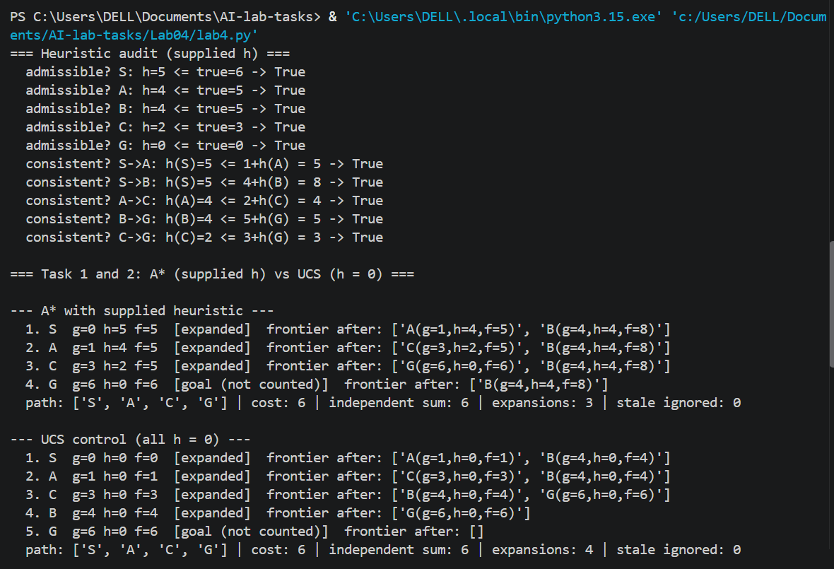
Figure 1: Terminal output of lab4.py: heuristic audit (admissibility and consistency), A* trace with the supplied heuristic, and UCS control trace.
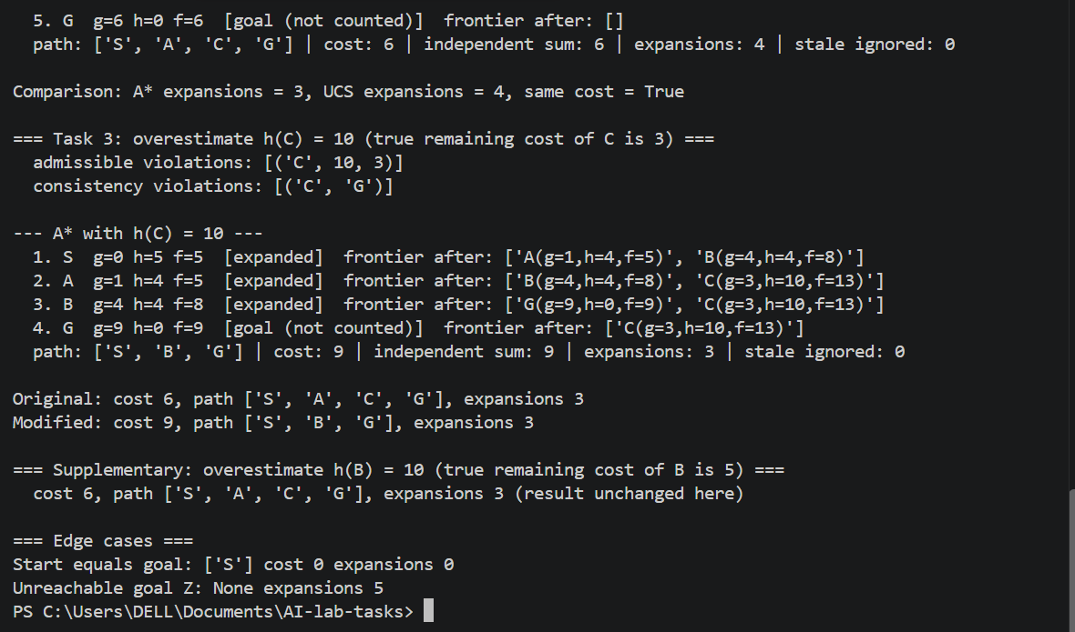
Figure 2: Terminal output of lab4.py (continued): A* vs UCS comparison, the h(C) = 10 overestimate experiment, the supplementary h(B) = 10 run, and the edge cases.

9. Edge-Case Tests
Test | Input | Result
Start equals goal | Start S, goal S | Path [S], cost 0, 0 expansions
Unreachable goal | Goal Z with no corridor from S | No path (None) after exploring all 5 reachable nodes
Zero heuristic | All h = 0 | Same behaviour as UCS (Section 6.2)
Overestimate | h(C) = 10 | Cost-9 path returned (Section 7.1)

10. Failure / Edge-Case Analysis
Item | Detail
Input | Supplied graph with only h(C) changed from 2 to 10, start S, goal G
Observed behaviour | A* returned S -> B -> G with cost 9 instead of S -> A -> C -> G with cost 6.
Likely cause | h(C) overestimates the true remaining cost (10 > 3), so f(C) = 13 ranks C behind G reached through B (f = 9). The heuristic is no longer admissible or consistent.
Proposed improvement | Check admissibility before trusting a heuristic, as in Section 5, or cap each estimate by a known lower bound. For a larger graph, test the heuristic against exact costs from a backward Dijkstra run.

11. Limitations
- The graph has only 5 nodes, so the A* advantage is 3 expansions against 4. This does not show how much A* helps on large maps.
- The heuristic values are supplied abstract estimates, not measured distances.
- Admissibility is verified only for this instance by comparing with the true costs.
- Consistency is checked for each edge. A heuristic that is admissible but not consistent can need re-expansions in graph search.

12. Reflection
1. Lab 4 mein kya naya samajh aaya? Mujhe samajh aaya ke A* mein f = g + h hota hai, jahan g ab tak ka asli cost hai aur h baaki cost ka andaza. Is lab mein A* ne 3 nodes expand kiye aur UCS ne 4, lekin dono ka cost 6 hi tha.
2. Kahan atke ya kya ajeeb laga? Pehle terminal mein py command >>> wale Python prompt mein chalayi to SyntaxError aa gaya. Phir exit() karke PS prompt par chalayi to theek ho gaya. Ajeeb ye laga ke sirf h(C) ko 2 se 10 karne par answer 6 se 9 ho gaya, jabke expanded nodes ki ginti 3 hi rahi.
3. Isay kahan use kar sakte ho? Navigation app (jaise Google Maps) mein raasta dhoondne ke liye, ya game mein character ke path ke liye. Lekin heuristic ko pehle asli costs se check karna zaroori hai, warna ghalat raasta mil sakta hai.
4. Agle lab mein kya alag karoge? Code chalane se pehle terminal ka prompt check karunga. Aur trace pehle hath se likh ke phir code se match karunga, taake galti jaldi pakdi jaye.

13. Responsible-Practice Response
Claims about efficiency are based on the counts printed by the code on the same graph, not on assumptions about path length. The weights and heuristic values are abstract lab values and not real campus data. A real navigation system would need verified map data and safety constraints, for example avoiding closed routes. The code uses no credentials or private data and follows the guided example in the lab manual [1].

References
[1] CAI601400 Artificial Intelligence Lab Manual, Lab 4: Informed Search: Heuristics & A*.
[2] P. E. Hart, N. J. Nilsson and B. Raphael, "A Formal Basis for the Heuristic Determination of Minimum Cost Paths," IEEE Transactions on Systems Science and Cybernetics, vol. 4, no. 2, pp. 100-107, 1968.
[3] S. Russell and P. Norvig, Artificial Intelligence: A Modern Approach, 4th ed., Pearson, 2020 (Chapter 3: Solving Problems by Searching).

